KRISHNA ENGINEERING COLLEGE

Practical file of data structure

NAME :-FIZA BANOO

ROLL NO :-19101610100067

COURSE:- B.TECH

BRANCH:- CSE

SEM:- 3rd

1 :- Wap for binary search.

#include<stdio.h>

#include<conio.h>

int main(){

int a[100],n;

printf("enter no. of elements\n");

scanf("%d",&n);

printf("enter elements\n");

for(int i=0;i<n;i++){

scanf("%d",&a[i]);

}

printf("enter search element\n");

int s;

scanf("%d",&s);

int first=0;

int last=n-1;

int middle=(first+last)/2;

while(first<=last){

if(a[middle]<s){

first=middle+1;

}

else if(a[middle]==s){

printf("position:%d",middle+1);

break;

}

else{

last=middle-1;

}

middle=(first+last)/2;

}

if(first>last){

printf("not found");

}

}

OUTPUT:-

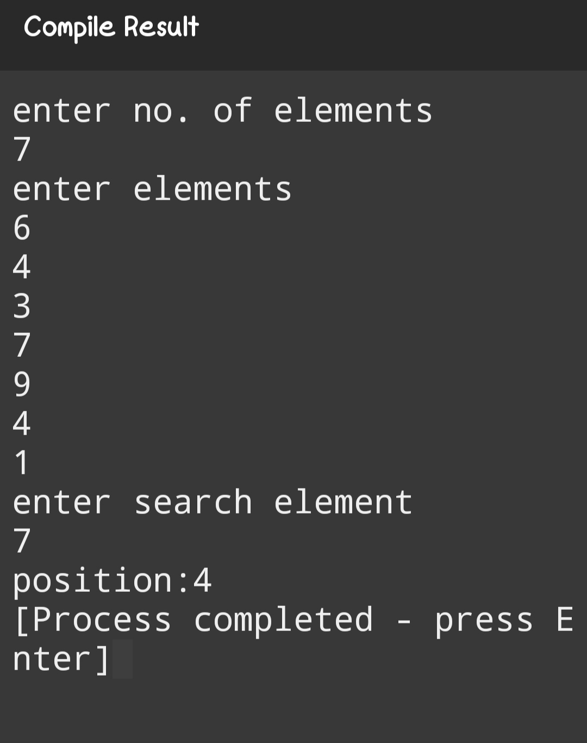

2:-Implementation of linear search?

#include<iostream>

using namespace std;

int main()

{

int a[100],n;

printf("enter no. of elements\n");

scanf("%d",&n);

printf("enter elements\n");

for(int i=0;i<n;i++)

{

scanf("%d",&a[i]);

}

printf("enter search element\n");

int s;

scanf("%d",&s);

int f=0;

for(int i=0;i<n;i++)

{

if(a[i]==s)

{

printf("position:%d",i+1);

f=1;}

if(f==0)

{

printf("element not found");

}

}

return 0;

}

OUTPUT:-

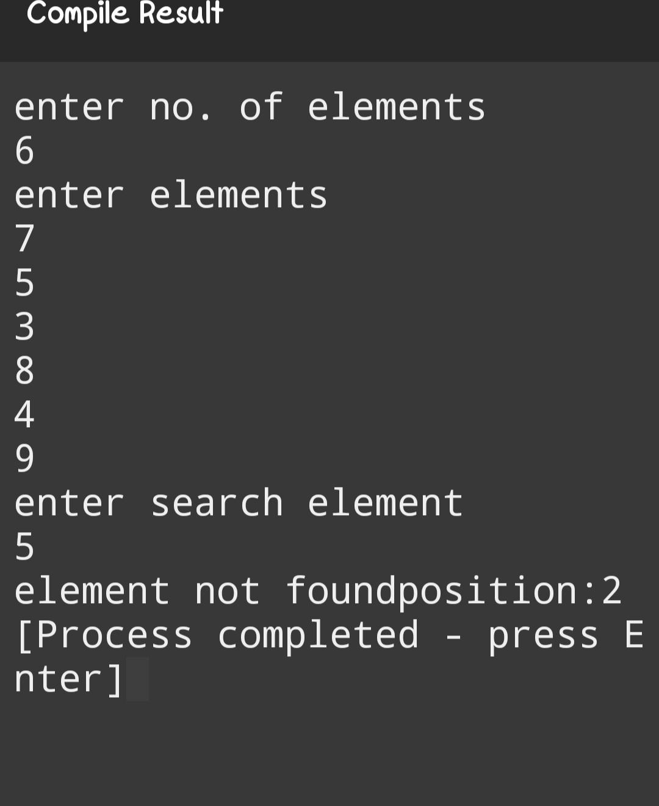

3:- Wap in c to perform a traversal of an array?

#include <stdio.h>

void printArray(int\* arr, int n)

{

int i;

Printf("Array: ");

for (i = 0; i < n; i++)

{

printf("%d ", arr[i]);

}

printf("\n");

}

int main()

{

int arr[] = { 2, -1, 5, 6, 0, -3 };

int n = sizeof(arr) / sizeof(arr[0]);

printArray(arr, n);

return 0;

}

Output

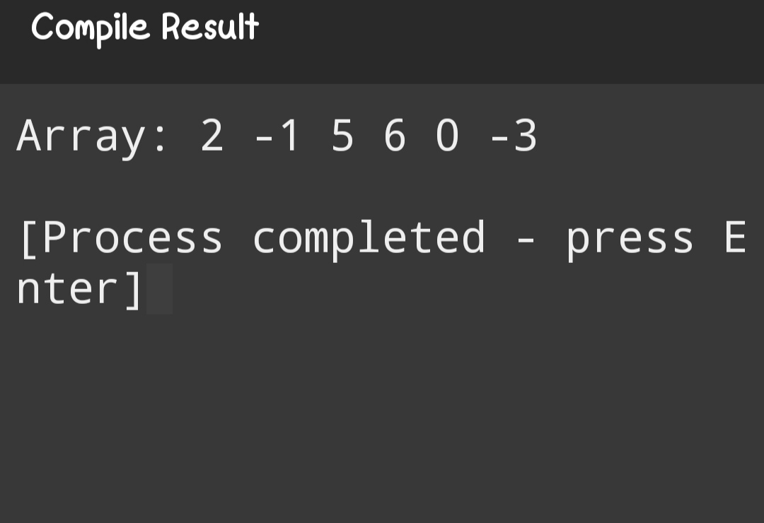

4:-Wap in c for insertion sort.

#include <stdio.h>

#define MAX 100

int main()

{

int arr[MAX],limit;

int i,j,temp;

printf("Enter total number of elements: ");

scanf("%d",&limit);

printf("Enter array elements: \n");

for(i=0; i<limit; i++)

{

printf("Enter element %3d: ",i+1);

scanf("%d",&arr[i]);

}

for(i=1; i<(limit); i++)

{

j=i;

while(j>0 && arr[j]<arr[j-1]

{

temp=arr[j];

arr[j]=arr[j-1];

arr[j-1]=temp;

j--;

}}

printf("Array elements in Ascending Order:\n");

for(i=0; i<limit; i++)

printf("%d ",arr[i]);

printf("\n");

return 0;

}

Output:-

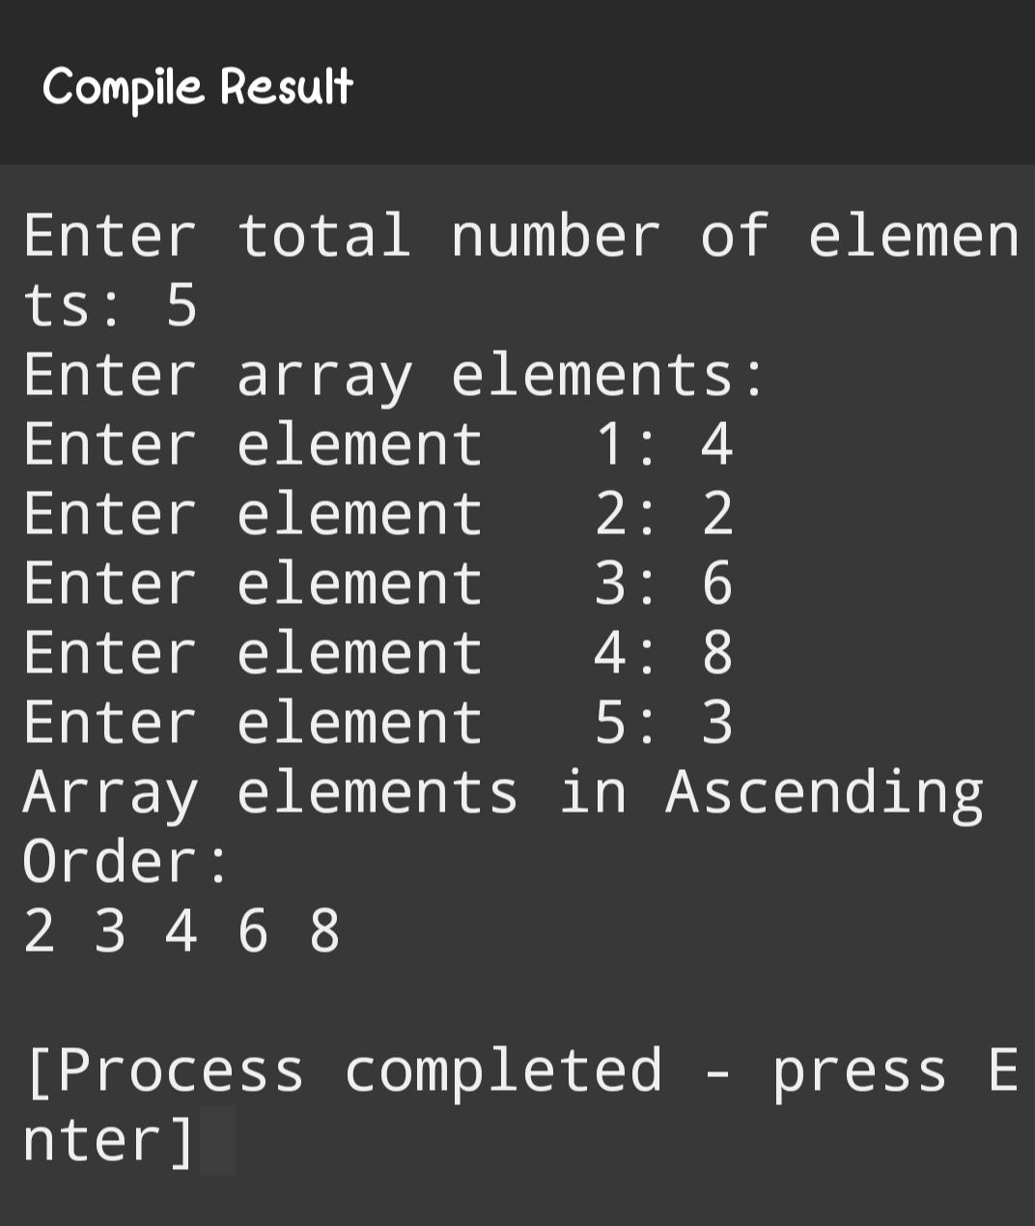

5:- Wap in c for selection sort.

#include <stdio.h> #define MAX 100

int main()

{

int arr[MAX],limit;

int i,j,temp,position;

printf("Enter total number of elements: ");

scanf("%d",&limit);

printf("Enter array elements: \n");

for(i=0; i<limit; i++)

{

printf("Enter element %3d: ",i+1);

scanf("%d",&arr[i]);

}

for(i=0; i<(limit); i++)

{

position=i;

for(j=i+1; j<limit; j++)

{

if(arr[position]>arr[j])

{

position=j;

}

if(position!=i)

{

temp=arr[i];

arr[i]=arr[position];

arr[position]=temp;

}

}

}

printf("Array elements in Ascending Order:\n");

for(i=0; i<limit; i++)

printf("%d ",arr[i]);

printf("\n");

return 0;

}

Output:-

